**VISVESVARAYA TECHNOLOGICAL UNIVERSITY**

**“Jnana Sangama”, Belagavi, Karnataka, India.**

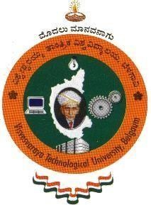

A Report On

**AICTE ACTIVITY POINT PROGRAMME**

*Submitted in partial fulfillment of the requirement for the award of the degree of*

**Bachelor of Engineering in**

**Information Science and Engineering**

*Submitted By*

**K SAI SHARAN REDDY**

**1DT19IS053**

*AICTE Department Coordinator* **Prof. Spandana S G Assistant Professor,**

**Dept. of ISE**



**Department of Information Science and Engineering**

**(Accredited by NBA 2022-2025)**

**DAYANANDA SAGAR ACADEMY OF TECHNOLOGY AND MANAGEMENT**

Kanakapura Road, Udayapura, Bengaluru- 560082

**2022–2023**

**DAYANANDA SAGAR ACADEMY OF TECHNOLOGY AND MANAGEMENT**

**Department of Information Science and Engineering Bengaluru – 560082**



**CERTIFICATE**

This is to certify that **K SAI SHARAN REDDY**, bearing **1DT19IS053** of 8th semester has completed "AICTE ACTIVITY PROGRAM" in partial fulfillment for the award of degree in Bachelor of Engineering in **Information Science and Engineering** of the Visvesvaraya Technological University, Belagavi during the year 2019-2023. It is certified that all corrections/suggestions indicated for internal assessment have been incorporated in the report deposited in the department library. The project report has been approved as it satisfies the academic requirements for Bachelor of Engineering Degree.

**Prof. Spandana S G**

**Assistant Professor** Dept. of ISE

DSATM, Bengaluru

Dr. Nandini Prasad K S

Dean - Foreign Affairs & Head Dept. of ISE

DSATM, Bengaluru

**ACKNOWLEDGEMENT**

The satisfaction and the euphoria that accompany the successful completion of any task would be incomplete without the mention of the people who made it possible. The constant guidance of these persons and encouragement provided, crowned our efforts with success and glory. Although it is not possible to thank all the members who helped for the completion of the AICTE Activity work individually, I take this opportunity to express my gratitude to one and all.

I am grateful to the management and our institute **DAYANANDA SAGAR ACADEMY OF TECHNOLOGY AND MANAGEMENT** with its very ideals and inspiration for having provided me with the facilities which made this work a success.

I express my sincere gratitude to **Dr. M Ravishankar**, Principal, Dayananda Sagar Academy of Technology and Management for the support and encouragement.

I wish to place on record, my grateful thanks to **Dr. Nandini Prasad K S**, Dean-Foreign Affairs and HoD-ISE, Dayananda Sagar Academy of Technology and Management, for the constant encouragement provided to me.

I am indebted with a deep sense of gratitude for the constant inspiration, encouragement, timely guidance and valid suggestion given to me by my guide **Prof. Spandana S G ,Assistant Professor**, Department of ISE, Dayananda Sagar Academy of Technology and Management.

I am thankful to all the staff members of the department for providing relevant information and helped in different capacities in carrying out this AICTE activity work.

Last, but not least, I owe my debts to my parents, friends and also those who directly or indirectly have helped me to make the AICTE a success.

**K Sai Sharan Reddy [1DT19IS053]**

**ACADEMIC YEAR AND BATCH (2019-2023)**

|  |  |  |  |  |  |  |
| --- | --- | --- | --- | --- | --- | --- |
| **NAME OF THE STUDENT** | | | **K SAI SHARAN REDDY** | | | |
| **STUDENT USN** | | | **1DT19IS053** | | | |
| **SEMESTER AND SECTION** | | | **8 A** | | | |
| **REGULAR/ REPEATER/ LATERAL ENTRY** | | | **REGULAR** | | | |
| **TITLE OF ACTIVITY** | **PLACE OF ACTIVITY** | **DATES OF ACTIVITY** | **HOURS OF ACTIVITY** | **MAXIMUM POINTS** | **POINTS SECURED** | **REMARKS** |
|  |  |  |  |  |  |  |
|  |  |  |  |  |  |  |
|  |  |  |  |  |  |  |
| **TOTAL ACTIVITY POINTS SECURED** | | |  | | | |
| **SIGNATURE OF THE STUDENT** | | **NAME AND SIGNATURE OF THE PROCTOR** | | **NAME AND SIGNATURE OF HEAD OF THE DEPARTMENT** | | |

**TABLE OF CONTENTS**

|  |  |  |
| --- | --- | --- |
| **CHAPTER NO.** | **TITLE** | **PAGE NO.** |
| **1** | **PLASTIC FREE AWARENESS PROGRAM** | **4-9** |
| **2** | **PLANTATION FOR BETTER ENVIRONMENT** | **10-14** |
| **3** | **CYBER SAFE GIRL** | **14-42** |
| **4** | **CERTIFICATES** | **43-44** |

# LIST OF FIGURES

|  |  |  |
| --- | --- | --- |
| **Fig. No.** | **Name of the figure** | **Page No.** |
| 1.1 | Poster | 5 |
| 1.2 | Meeting local people | 6 |
| 1.3 | Interaction with nearby people of college | 7 |
| 1.4 | Showing teamwork | 7 |
| 1.5 | Local area vendor | 8 |
| 1.6 | Team work for awareness | 8 |
| 1.7 | Interaction with plastic awareness with kid | 9 |
| 1.8 | Travelling pics | 9 |
| 2.1 | Planting of saplings | 13 |
|  | Certificates | 44-45 |
|  |  |  |

***CHAPTER 1***

# PLASTIC FREE AWARENESS PROGRAM

# TASK PERFORMED

**DURATION:80 hrs( 23rd June 2022 to 29th June 2022)**

**Activity start date**: **23 June 2022**

###### DAY 1: 23rd June 2022

We have prepared templates/Posters on this day.Posters give pictorial representation which is helpful for easy explanation.

###### DAY 2: 24th June 2022

This day we were taken to a village named thittahalli and Mukkodlu which belonged to Somanahalli panchayat where we prepared banners related to less usage of plastic and they reached out homes and public and each of the team explained them the effect of using more plastic.

###### DAY 3: 25th June 2022

We have explained the importance of plastic free environment on this day.

###### DAY 4: 26th June 2022

We have performed many activities to show how plastic harms our environment.

**DAY 5: 27th June 2022**

They also explained them the future problems that will occur due to usage of more plastic.This program has brought us a lot of information about creating awareness and talking to people. We reached homes of the people living in those areas and explained our views on usage of plastic and also created very good awareness in the society.

**DAY 6: 28th June 2022**

We have told them about 4 R’s:Reduce, Reuse, Recycle and Recover & its importance.

**DAY 7: 29th June 2022**

On final day of session finally we have completed our moto of making the village aware about plastic free environment.

**Spreading Public Awareness Under Rural Outreach Programme**

### Say No to Plastic || Stop Plastic Pollution Poster drawing for School || How to Draw Save Earth - YouTube | Poster drawing, Pollution activities, Earth day crafts

Fig 1.1 showing the poster for awareness

### About the activity:

As a part of an AICTE Activity we were taken out to a rural area to create public awareness about reducing the use of plastic. It was such a great initiative taken by the department to promote awareness on the most important topic. These days we were taken to a village named thittahalli and Mukkodlu which belonged to Somanahalli panchayat where we prepared banners related to less usage of plastic and they reached out homes and public and each of the team explained them the effect of using more plastic. also explained them the future problems that will occur due to usage of more plastic.This program has brought us a lot of information about creating awareness and talking to people. We reached homes of the people living in those areas and explained our views on usage of plastic and also created very good awareness in the society.The department has given us such an amazing opportunity to portray ourselves as something unique apart from academics.We have learned values and how to promote awareness.

### Snapshots/Pics:

\

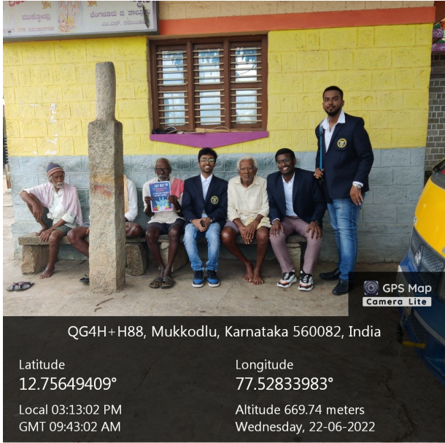

Fig 1.2 meeting a localite

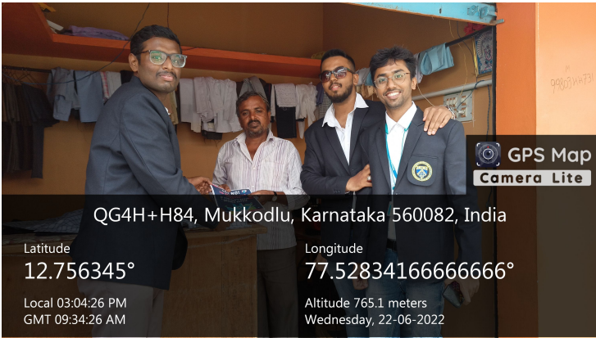

Fig 1.3 showing the interaction with the nearby people

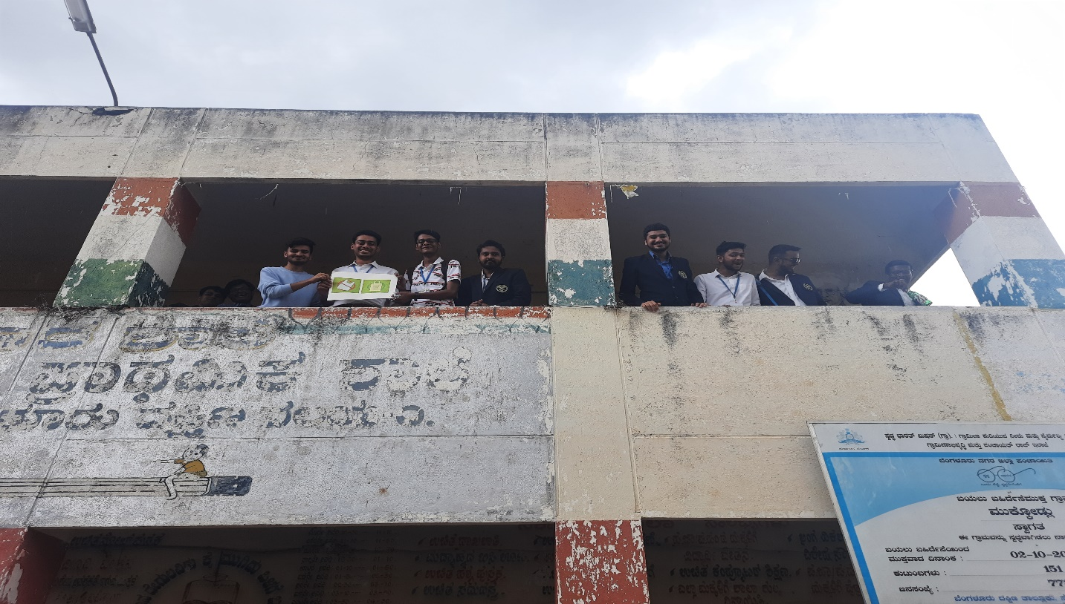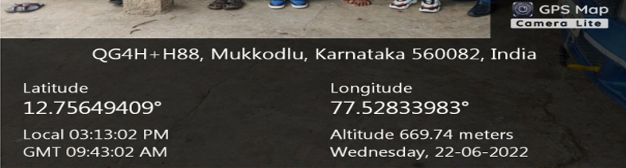

Fig 1.4 showing the teamwork required for awareness program

 Fig 1.5 showing the talk with the local area vendor

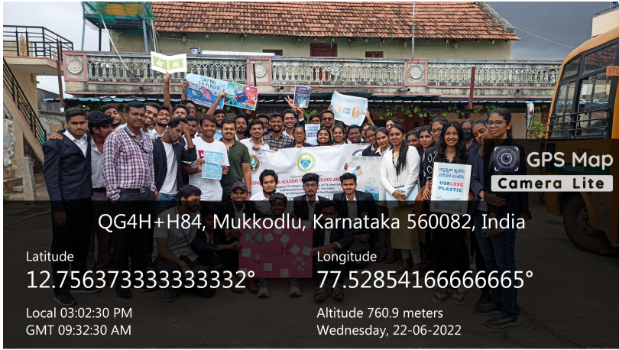

Fig 1.6 showing the team work for awareness

Fig 1.7 showing awareness to small kid

***CHAPTER 2***

# PLANTATION FOR BETTER ENVIRONMENT

#### 2.1 ABOUT THE ACTIVITY

#### Plantation is the process of planting trees and other vegetation to enhance the environment and combat climate change. The benefits of plantation are numerous, including carbon sequestration, soil conservation, air purification, and wildlife habitat creation. Trees absorb carbon dioxide from the atmosphere and release oxygen, which helps reduce the amount of greenhouse gases in the air. Additionally, planting trees and vegetation can help prevent soil erosion, filter pollutants from the air and water, and provide a home for wildlife. Plantation is an effective and sustainable way to improve the environment and combat climate change.

#### The benefits of plantation for the environment:

#### 1. Carbon sequestration: Trees absorb carbon dioxide from the atmosphere and store it in their biomass, which helps reduce the amount of greenhouse gases in the air. In fact, one mature tree can absorb up to 48 pounds of carbon dioxide per year.

#### 2. Soil conservation: Plantation can help prevent soil erosion by anchoring the soil with their roots and reducing the impact of wind and water. Trees also help to retain water in the soil, which can help prevent droughts.

#### 3. Air purification: Trees can filter pollutants from the air, including nitrogen oxides, ammonia, sulfur dioxide, and ozone. They also release oxygen into the air, which can improve air quality and reduce the risk of respiratory illnesses.

#### 4. Wildlife habitat creation: Plantation can provide a home for a variety of wildlife, including birds, insects, and mammals. Trees and vegetation can provide food, shelter, and nesting sites for these animals.

#### 5. Economic benefits: Plantation can provide economic benefits for communities, such as timber and non-timber forest products. These products can be used for building materials, furniture, and other products.

#### Overall, plantation is an effective way to improve the environment and combat climate change. It can provide numerous benefits, both ecological and economic, and can be implemented in a variety of settings, from urban areas to rural landscapes.

**2.2 Description of Activity**

As a part of an AICTE Activity, I had taken out to for planting the samplings, which in future grows into trees. Once the trees are established, they can provide long-term benefits to the environment, such as reducing carbon emissions, preventing soil erosion, and improving air and water quality. Plantation is an effective way to address climate change and promote sustainable development.

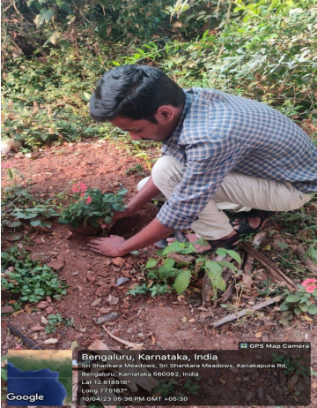

Fig.2.1 Planting of saplings

**2.3 OUTCOME OF THE ACTIVITY**

Plantations can have a positive impact on the environment if they are established and managed properly. Here are a few ways that plantations can contribute to a better environment outcome:

**1.Carbon sequestration:** Trees absorb carbon dioxide from the atmosphere and store it in their biomass. This process is known as carbon sequestration, and it can help to mitigate climate change by reducing the amount of greenhouse gases in the atmosphere. Plantations can be established specifically for carbon sequestration, and they can help to offset carbon emissions from other sources.

**2. Biodiversity:** Plantations can provide habitat for a variety of wildlife species, particularly if they are established in areas that were previously degraded or cleared. A well-designed plantation can include a mix of tree species and incorporate elements such as riparian buffers and wildlife corridors to maximize biodiversity benefits.

**3. Soil conservation:** Plantations can help to prevent soil erosion and improve soil quality. Tree roots can hold soil in place and prevent erosion, while fallen leaves and other organic matter can help to build soil fertility.

**4. Water conservation:** Plantations can help to conserve water resources by reducing water runoff and improving water quality. Trees can intercept rainfall and allow it to soak into the soil, reducing runoff and erosion. They can also absorb pollutants from runoff, improving water quality.

**5. Renewable resources:** Plantations can be established to provide a sustainable source of wood, fiber, and other renewable resources. This can help to reduce pressure on natural forests and other ecosystems, and can provide economic benefits to local communities.

**6.Air purification:** Trees absorb carbon dioxide and other pollutants from the air, improving air quality.

**7.Water conservation:** Trees help to slow down rainwater runoff and allow water to seep into the ground, which helps to recharge groundwater supplies.

**8.Biodiversity:** Trees provide habitat for many species of animals, birds, and insects, contributing to biodiversity and ecosystem health.

**9.Climate change mitigation:** Trees absorb carbon dioxide from the atmosphere, helping to reduce greenhouse gas emissions and mitigate climate change.

**10.Aesthetic value:** Trees and greenery can enhance the beauty of landscapes and make them more enjoyable for people to visit and use.

**11.Noise reduction:** Trees can help to reduce noise pollution by absorbing sound waves.

**12.Cooling effect:** Trees provide shade and help to cool down the surrounding area, reducing the urban heat island effect.

Overall, plantations can be an important tool for achieving environmental goals if they are established and managed in a way that maximizes their environmental benefits and minimizes their negative impact.

***CHAPTER 3***

# CYBER SAFE

**Duration:50 hrs**

This course contains 49 chapters:

**Chapter 3.1**

**MOBILE RECHARGE SHOP**

If you want to recharge your mobile phone, which is the place that you would go - a local mobile recharge shop near your house or by the customer care of the mobile service provider? Ideally, most of us would say the former one as it is more convenient. Did you know that this could be a potential source of being a victim of cybercrime?  
  
It is like giving off your personal information like phone number as well as ID proofs to a complete stranger. The stranger can send an SMS to your phone asking you to click on a link or scan a QR code which may result in money being debited from your account or in worse cases even your phone being hacked. being installed. The ID proof submitted to them might be used to create a fake identity in your name and can put you into trouble for something that isn’t your fault at all. The mobile recharge shop vendor who seemed extremely nice to you at the beginning over text could even manipulate you eventually. Hence being aware and not recharging your mobile with local recharge vendors would save you from a lot of trouble and help you stay safe.

**Chapter 3.2**

**DEBIT CARD CLONING**

We swipe our credit and debit cards at shopping malls, petrol bunks, ATM’s etc, little do we realise to check the swiping device for any extra parts attached before swiping our cards. These swiping machines may be fitted with an extra skimming device that reads your card details and your PIN and then the scamsters who inserted the device may use it for fraudulent transactions.  
The scamster may even be able to replicate the card and withdraw money from an ATM with the help of your card details and PIN that was obtained by the skimming device. Making sure that no one is peeping while you are entering your pin, as well as not sharing your PIN with anyone (including your friends) is a good practice to avoid being a victim of a fraudulent transaction. So the next time you step into an ATM, look around for spy cameras, check the place where you insert your card to check for any movable parts or extra fittings and if there is a pad over the keypad to capture your PIN. Be attentive, be careful and save your money from being transferred into the hand of scamsters.

**Chapter 3.3**

**KEYLOGGER**

Keyloggers are generally malicious programs or devices that are used by a hacker or scamster to capture your keystrokes. Which essentially means that if a keylogger is installed on the victim’s machine, the hacker can see the websites you visit, the passwords you type, the photos you view, your financial card details and even enable your webcam and microphone. Hence the hacker knows every move that you make on your system and this can be quite scary. The pictures taken by the hacker may be used to blackmail or even manipulate you.  
  
Keeping your laptop or phone updated with the latest software is extremely important and might even prevent such incidents from happening in the future. Also, make sure that you have antivirus in your systems which can scan for such keyloggers. Before using an ATM or entering your PIN make sure that you aren’t typing on any sort of pad coating instead of the keypad directly. Not leaving your unlocked laptops unattended and making sure you have a password for your device are also important steps to be taken to prevent your keystrokes from being captured by a stranger

**Chapter 3.4**

**SMS SPOOFING**

Spoofing is essentially deceiving the receiver of the sender’s id and number. So the sender pretends to be someone else just in order to get the user to click on a malicious link or to gain personal information of the receiver. A spoofed SMS is sent from the fraudster’s phone to the victim in order to entice the victim. The victim unaware of this type of cybercrimes might think it is genuine and since the sender’s name matches whom the sender pretends to be, the innocent victim is easily convinced.Watch out for such SMS’s that say you have an unreasonably huge sum of money or a free trip to a country on your bucket list. It is coming from a fraudster and you might just end up losing money or giving away your personal information only to be blackmailed later on. Beware and do not click on unnecessary links or even reply to any SMS from an unknown person. Remember that nothing comes free not even a toy car, so forget about winning 1 million dollars.

**Chapter 3.5**

**CALL SPOOFING**

Spoofing means to pretend to be someone that you actually are not. Fraudsters call people promising job interviews in their desired companies or saying they are interested in the product that you recently wanted to sell on a website. After a convincing conversation, people believe the fraudster who tells them to scan a QR code and in a few seconds, you notice that money has been debited from your account. There are incidents where the scamster pretends to be one of your friend in trouble and even changes his voice to make you believe it.  
  
There are certain easily available apps that allow the scamster to change their number in order to conduct call spoofing. Hence be careful and do not give away any of your personal details to anyone whom you do not trust over a call. Never share OTP’s or your debit card PIN’s with anyone. Having an app that shows the caller ID or suggests that it might be spam might also help against being a victim of spoofed calls.

**Chapter 3.6**

**RANSOMWARE**

Ransomware is a type of malware that encrypts your files and you need to either restore it from the latest backup that you have or pay the hacker in order to obtain the encryption key in order to access your files. About 50 percent of the time, even after paying the hacker the demanded amount, you might not get your files back. Also if your files contain sensitive customer information, such details will be exposed to the hacker which can ruin the reputation of your company.  
  
Phishing emails are one of the most common ways for ransomware to infect your network. Hence employees of the company must be trained and made aware to avoid clicking unnecessary links in emails or downloading attachments. Keeping your antivirus and operating system updated may also help prevent your systems from getting infected with ransomware.

**Chapter 3.7**

**CYBER STALKING**

Cyberstalking is using the Internet to stalk or harass someone based on the information on their social media accounts. Letting people know where you are at a given point of time, the restaurants you are visiting etc. gives people more information about you. Keeping your social media accounts public lets even strangers know about your family, friends, common places you visit and sometimes even where you stay. This means that a person with a wrong intention may even follow you home since they know where you stay through the information that you have shared on social media.  
  
Be careful with the friends you make on social media. Think before you post personal information or even your current location on the Internet. Accept only requests from the people you know and preferably ensure to keep your profile private. Be careful and stay safe.

**Chapter 3.8**

**PICTURE MORPHING**

Morphing the face of one person to the body of another person and publishing it online in order to blackmail the victim is called picture morphing. This is often done as an act of revenge by a previous acquaintance or by a complete stranger. Sharing pictures with a person you recently made friends with on social media is hence not safe as he could misuse those pictures. Make sure to keep your profile private and accept friends requests from only the people you know.  
  
While uploading pictures on the Internet, make sure they are not clear images as they can be easily morphed. Hackers do not need expensive tools to morph pictures. It can be done easily with the click of a button, hence think twice before sharing pictures on social media. Personal information like phone number should be considered twice before uploading it on your social media accounts.

**Chapter 3.9**

**PROFILE HACKING**

Keeping a watch on the kind of games your children or little ones are playing is soo important in this current generation. Most of the kids download and play the games without knowing the consequence it has on their body and mind. Especially for kids and teenagers who are more likely to get depression and have low self-esteem may harm themselves while playing such toxic games. This may become addictive overtime and even may lead to killing oneself in the worst cases.  
  
Hence it is important as adults to keep a watch and completely know what type of games the kids and teenagers are downloading and playing. Also if behavioural changes are noticed in kids after playing certain online games, then that must be treated properly and must be advised accordingly.

**Chapter 3.10**

**ONLINE GAMES**

An email account or social media account being hacked by a hacker is called Profile Hacking. Forgetting to log out of your accounts on public computers might enable the next person using the system to reset the password of your account and hence hack your account. Hence logging out of all public computers is extremely important to protect your account from being hacked.  
Also accessing your email and social media accounts when you are connected to a free Wifi at restaurants, airports, or public places might make it easy for a person to capture your passwords and hence it must be avoided.  
  
While setting passwords of your social media accounts it is important to choose a strong password and not reuse the same password across all accounts. Make sure not to share your passwords with other people. Logging out of all accounts and enabling two-factor authentication might also help prevent your social media account from being hacked.

**Chapter 3.11**

**JOB CALL LETTER**

While you are in search of a job, you upload your contact details on multiple websites that say that they will help you find a job. During such desperate times, none of us actually put in the effort to check whether the website is genuine before we apply on it. This is one extremely crucial step that we miss and hence we may be a victim to a fake job offer. Often calls are also received from several agencies promising to give you the opportunity of attending an interview at your dream company in return for a few thousand.  
  
Websites offering jobs must be checked for its authenticity and mails received from the companies you apply to must be checked before going for an interview. All you know it might just be a phishing mail. Remember that even though you register on websites offering jobs, none of them nor the companies you apply to require you to pay any money. It is also important to verify the details of the company that you are going to interview for, before going for the interview in order to make sure it is genuine.

**Chapter 3.12**

**DEEPFAKES**

Deepfake is basically a technology to combine and superimpose new images and videos onto source images and videos. This is done in such a way that the viewer cannot doubt the truthfulness of it. Deepfakes are generally done by people who have some technical knowledge as it uses artificial intelligence in order to superimpose the images or voice. This can be used to manipulate or blackmail an innocent victim.  
  
Hence it is important to not upload your clear photos and videos on any social media platform. People with wrong intentions can use those pictures itself to create a deepfake and make it viral to bring down your reputation. Since deepfakes use some amount of technical knowledge in order to create it, hence it looks as close to real as possible.

**Chapter 3.13**

**DATING WEBSITE**

Girls are often emotionally manipulated by people who seem to be extremely nice at the beginning but might actually just want to take advantage later on. Dating websites are one such platform which has made this easier online. Girls trust the person they just started texting on a dating website and share all personal information as well as pictures with them without even getting to know them properly. Sometimes if the boy even asks for a lot of money, the girl lends money without even thinking twice and this transaction might turn out to be their last conversation if the guy turns out to be a scamster instead.  
  
Hence, girls must be extremely careful when they are using such dating websites. It is important to not trust the person blindly but instead to get to know all details about the person they just met on the dating site before trusting him. Be careful while sharing private pictures and videos and stay alert and stay safe.

**Chapter 3.14**

**CAMERA HACKING**

Girls are often emotionally manipulated by people who seem to be extremely nice at the beginning but might actually just want to take advantage later on. Dating websites are one such platform which has made this easier online. Girls trust the person they just started texting on a dating website and share all personal information as well as pictures with them without even getting to know them properly. Sometimes if the boy even asks for a lot of money, the girl lends money without even thinking twice and this transaction might turn out to be their last conversation if the guy turns out to be a scamster instead.  
  
Hence, girls must be extremely careful when they are using such dating websites. It is important to not trust the person blindly but instead to get to know all details about the person they just met on the dating site before trusting him. Be careful while sharing private pictures and videos and stay alert and stay safe.

**Chapter 3.15**

**SOCIAL TROLLING**

With this current era where most people are on social media, a lot of hate is spreading among people through social media. One such incident is social trolling, which basically means making fun or posting inflammatory comments and posts in order to just cause a nuisance to a person. People do not consider this to be a huge cybercrime but it affects a lot of people’s mental health. People who are vulnerable to clinical depression or having low self-esteem might get severely affected by such comments and posts.  
  
The victim also loses her reputation and gets more scared to talk to her parents about this. Most of such cases are just ignored or the victim thinks it is okay to suffer through it. Although, it is extremely important to inform adults or even lodge a complaint in the police station if it is a severe case.

**Chapter 3.16**

**PONZI SCHEME**

A Ponzi Scheme is a fraudulent investment scheme that promises high rates of return with little risk to investors. Afterall somethings are too good to be true. Victims who believe in such schemes are vulnerable to hackers who promise to recover their loses. When you have already lost money in a particular investment scheme, you want to the money somehow without even thinking about checking the truthfulness of the hacker. Hence, making decisions in a haste might not be the right way.  
  
Always check the right schemes and something that is more realistic before investing. Even if after all that you have done, you get cheated on, take time and check the truthfulness of anyone who says that they will return your money back. Stay safe and let us hope you do not get tricked twice.

**Chapter 3.17**

**FAKE MATRIMONIAL PROFILE**

A fraudster who has registered on a matrimonial site with his fake profile might start texting a girl and eventually make a girl fall for him. The profile photo and details may not even be his since it is a fake profile. The girl however believes and trusts this person and assumes he is the person who he is pretending to be. During his difficult times, she may even give me some lakhs of rupees and then the man might disappear after receiving the money. This is when the girl releases that it is a fake profile but by then it is already too late.  
  
Such kind of fraudsters exists, who cheat on multiple such women with the same modus operandi. Hence being aware and doing some background verifications too while you meet people on matrimonial sites goes a long way and might help prevent being cheated by people having fake matrimonial profiles.

**Chapter 3.18**

**MOBILE REPAIR SHOP**

Do you go to the official store if your mobile doesn’t work or do you go to any mobile repair shop close to your house? The latter is where the risk arises. In case you go to the mobile repair shop and drop off your phone telling the vendor that you will collect it in a while, then he has access to all your photos, videos, messages and contacts. Is locking your phone with a pattern or passcode enough to prevent him from accessing this personal information? Certainly not, since the patterns and passcodes can be easily cracked with the help of hacking software.  
  
Furthermore, those pictures can be used to blackmail the victim. Hence it is important to get the phone repaired at the official store itself instead of a local repair shop. Also preferably it is better to wait till your phone gets repaired than leaving it with him itself. Be careful and stay safe

**Chapter 3.19**

**FAKE REVIEWS**

Fake reviews are least realised in any product on any website. Some products might have fake reviews just in order to increase the sales of that product. Hence they trick customers into buying that particular product. Sometimes these wonderful reviews are backed by exciting discounts and offers in order to entice the customers even more. At times such products may even cause untold harm if used.  
  
Hence before you buy a product, buy from a genuine website and look at the genuine reviews. A lot of browsers allow you to install extensions that might help identify fake reviews. Also, look at the total number of reviews while checking out the percentages of reviewers who liked the product. Keep your skin safe and trust only websites and products that show genuine reviews.

**Chapter 3.20**

**FAKE PROFILE WITH SEXTORTION**

Any public changing rooms or public washrooms might have cameras placed to capture pictures with criminal intent. These pictures are later uploaded on fake social media profile with the intention of extortion. The helpless innocent victims end up paying huge sums of money for that to be removed from social media and for no fault of theirs. But by that time it would have already been sent to the victim’s family and friends.  
  
Hence it is important to check for any spy cameras in any public changing rooms or washrooms. Also, check for 2-way mirrors and report any sort of blackmailing to the police officials at the earliest. Stay safe and report it at the earliest.

**Chapter 3.21**

**CYBER VULTURES**

An organisation or person has currently just faced a cyber attack and these hackers again try to attack them, These merciless breed of hackers are called cyber vultures. They make use of the desperate state of mind of such people and try to swindle more money from them. Hackers call and convince you that they are genuine and that you will get your money back and hence manage to obtain the sensitive information like UPI code, ATM PIN etc. With this information he debits more money from the account, adding to much more damage. Amounts received in such transactions might be transferred to an unknown E-wallet company which refuses to comply with investigation agencies.  
  
Hence, it is important to be sure of random callers and never share your OTP or PIN with anyone. Also, verify the authenticity of the person or organisation who is trying to help you after a cyber attack. Firstly, try not to be a victim of a cyber attack in the first place and even if you become, do not succumb to another attack. Stay aware and stay safe.

**Chapter 3.22**

**APP TRAPS**

Before downloading any app onto your phone it is extremely important to know what exactly the app does. Some apps are known to just harvest data from your phone and transfer it to some person/organisation. These apps might request access to your storage, files, pictures, camera etc. and once you grant them the required permission, they can see all your photos, videos, sensitive documents and even capture photos and videos of you without your knowledge. The companies of such apps also sell your data and make a huge amount of money by this method.  
  
Therefore, it is important to always download apps from google play store and not from APK’s available online. Also, give permissions only as required. If an app does not actually make use of a camera , then you need not give it such permissions. Be aware of all the apps you have on your phone and make sure you know what each of them do. Be safe.

**Chapter 3.23**

**JUICE JACKING**

Have you charged your phone from public charging points like in airports, restaurants and malls? Have you ever wondered if it safe to charge from those sockets? Indeed, it might not be safe at all. Some charging ports might install malware or copy sensitive information from your phone or any other device. This especially happens in charging ports that doubles as a data connection, most likely over USB. In case you observe your phone becoming slower or hotter suddenly, and if you have been charging your phone at any public charging points, your phone might have some malware installed on it. Doing an antivirus scan will show the presence of malware and that is causing the reduction in speed and hence it is important to have an up to date antivirus. Think twice the next time your phone has a low battery and you want to charge it at a public charging point.

**Chapter 3.24**

**WIFI HACKING**

WiFi is a wireless technology that lets laptops, smartphones, smart TV’s etc. connect to it in order to be connected to the Internet. Most homes and offices nowadays have a WiFi with multiple devices connected to it. When your house gets a WiFi it comes with a default password and most of the times it remains unchanged. WiFi hacking is essentially cracking the password of your WiFi. If your neighbour wants to use your WiFi, he might just try the default password that you haven’t changed yet and directly start using your WiFi. Do not be surprised if you get a huge bill or notice that your internet speed has decreased.  
  
Keeping weak passwords lets hackers get connected to your WiFi and then can view, store, download or abuse your network. Also, people with bad intensions can connect to your WiFi and commit crimes like sell drugs etc. which causes trouble for no fault of yours. Hence, it is important to keep a strong WiFi password and have a check at the people logged onto your WiFi frequently.

**Chapter 3.25**

**ONLINE RADICALIZATION**

A lot of teenagers and young adults might fall prey to online radicalization or terrorist’s propoganda while surfing the internet. The extremists target individuals who are weak minded or currently going through financial difficulties in their life. They lure them with some amount of money and inculcate terrorist ideologies in their mind. Such gullible people often fall prey to such forms of online radicalization because of either a weak upbringing or past experiences.  
  
The mind can be easily manipulated and hence it is important to not blindly believe anything. Check the facts and check if this is the thing that you believe in and are not forced in endorsing it because of external pressure. Question your integrity and morality before trying to believe or do as the extremists say. Have your own ideologies and stay strong and stay safe.

**Chapter 3.26**

**HONEY TRAP**

Honey is always sweet but as they say life is not always sweet. Honey trapping is using romantic or intimate relationships just for an interpersonal, political and monetary purpose. Girls trust men who compliments them and gets close to them in sometime. Little do you know that the person might have an hidden motive behind it. He might just want some money from you or some sensitive information. Once his motive is achieved, he will no longer contact you or keep in touch.  
  
Hence, once you become friends on the Internet, it is important to do a background check and get to know a person properly before trusting him directly. Also they may use your pictures or videos and then may later blackmail you just in order to get some money. In this current era, with the increased use of social media platforms, it makes it easier for people to blackmail

**Chapter 3.27**

**QR CODE SCAM**

QR code is a 2 dimensional barcode which was initially used to make it easier for people to search websites. Just one scan of the QR code would take you to the exact URL that you are interested in instead of typing the entire URL in the search bar. But however nowadays, this is being misused as any URL can be embedded in a QR code. Half the payments that are done on a daily basis happen by just scanning QR codes these days. QR codes are sent by scamsters to innocent people and they tell them to scan their code and within seconds money gets debited from their account.  
Hence it is important to remember not to scan any QR code unnecessarily. Also since all QR codes look the same you might never know what the real intention behind the QR code is. Therefore if it is someone you do not trust, it is always better to enter the URL by yourself itself. Your phone can also get hacked by just scanning a QR code, so be careful.

**Chapter 3.28**

**RFID CLONING**

RFID refers to Radio Frequency Identification which is a method of automatic authentication of objects and object ID’s using radio waves. Each RFID chip contains an identifier which consists of a unique number and an antennae. Hence most RFID cards can be easily cloned.  
  
It is important to not leave your RFID cards unattended as someone might get an RFID card reader and scan your RFID thereby obtaining all details. It therefore can be easily replicated and can be used to gain access to all the things you have access to with that RFID card.RFID cards are mainly used in offices as an access card to some of the most confidential rooms like server rooms and only limited people have access to it. Hence if your RFID gets cloned someone else might have access to it and if anything is tampered then you might be blamed for it with no fault of yours.

**Chapter 3.29**

**DRONE SURVEILLANCE**

A drone refers to an unpiloted aircraft. Drones are used for a variety of purposes like detecting cracks on railway tracks, delivery of medicines and goods , to take videos and pictures etc. Drones typically have a camera fixed to them in order to capture images and videos during the day as well as in the night. Even though drones are extremely useful for a lot of purposes, they can be misused as well. They maybe able to intercept cell phone calls, determine GPS locations, gather license plate information, and go even where a human can physically not step in.  
  
People can hover drones outside your bedroom and take pictures of you without your knowledge. They can also intercept and crack your WiFi password as well as drop some hazardous weapons. A CCTV camera with a motion sensor maybe helpful in detecting a drone and could help prevent such an incident from occuring.

**Chapter 3.30**

**SEARCH ENGINE RESULTS SCAM**

All that you search on Google may not be actually genuine websites. Hackers can create a legitimate looking website and make it appear in your search results. Since it appears in your results, you might assume that it actually is genuine and hence might view the website. However a lot of your results might just be to mislead you. Do not trust any customer care or helpline number that you come across on your seach result. It might just be a fake number and you might end up giving away your personal information to an unknown person, or in worse cases even end up giving money to the wrong person.  
  
This Search Engine Optimization scam can trick a lot of users and hence it is important to check the authenticity of a site or helpline number before falling prey to one of them. Beware and do not share your CVV with anyone or give out any personal information to a complete stranger. Do not see and blindly believe without verifying the truthfulness.

**Chapter 3.31**

**IDN HOMOGRAPH ATTACK**

The internationalized domain name (IDN) homograph attack is used to form domain names that visually resemble legitimate domain names, albeit, using a different set of characters. For example, the IDN "xn--akmai-yqa.com" which appears in unicode as "akámai.com" visually resembles the legitimate domain name "akamai.com". Attackers often apply IDN homograph attacks to form domain names that are used for malicious purposes, such as malware distribution or phishing, while appearing trustworthy to victims.  
  
An IDN homograph attack is similar to another type of domain name spoofing known as typosquatting. Both techniques attempt to deceive users by using a new domain name that’s similar to an established name, although they exploit different types of similarities. Typosquatting uses a new domain name that’s spelled differently from the established name, but uses the same character set. A homograph attack typically uses a domain name that contains characters from other character sets, which requires the user to click on a hyperlink of the new name. This type of attack rarely works with a manual entry of the domain name since a user is unlikely to unintentionally enter a homograph.  
  
Some domain names can be used for both typosquatting and homograph spoofing. For example, a spoof that uses a domain name containing an uppercase “O” instead of the numeral “0” would be both types of attack. The success of this type of spoof is highly dependent on the typeface the computer uses, as these two characters are physically identical in some typefaces.

**Chapter 3.32**

**SCRATCH CARD SCAM**

There are a variety of fraudulent or deceptive schemes prevalent online, where people are asked to make payments/ share account details or OTP/participate in money multiplying schemes etc. via email, phone or text. Fraudsters use many methods to conduct scams, including requesting gift cards from well-known brands for payment.  
  
While the specifics of the scams vary, scammers generally follow a common pattern: they connect with a victim by phone, email, through social media, or online; they create a sense of urgency (for example: by offering a great price or mentioning a personal hardship or emergency); they ask for payment using gift cards; and they instruct the victim to purchase gift cards online. The scammer then demands or instructs the victim to provide the email with a claim code on the gift card by phone, text message, or email - and then disappears.

**Chapter 3.33**

**SIM SWAP**

SIM swap fraud is an account takeover scam that targets a weakness in some forms of two-factor authentication in which a call or text message sent to a mobile telephone is the second factor or step. Also known as port-out scam, digital SIM swap, SIM splitting, and simjacking, the SIM swap scam exploits the ability of subscriber identity module (SIM) cards to be ported seamlessly by mobile phone service providers from device to device bearing different telephone numbers. Typically, carriers use this feature when customers buy new phones, switch service, lose their device, or experience theft.  
  
At its most basic level, during a SIM swap, a SIM hijacker convinces your mobile carrier to port your phone number over to their SIM card. By transferring those incoming messages, fraudsters can easily access your most sensitive accounts by completing text-based two-factor authentication checks. If you’ve failed to protect accounts with 2FA, they can use the phone number to generate existing and new passwords. They can also take over social media accounts, retail accounts, and any other accounts linked to the phone number—which is probably any online account.  
  
The primary goal of SIM swap fraud is typically financial gain, often in the form of stealing bank and credit card information. However, sometimes a SIM swap attack might be intended to embarrass or humiliate the victim when compromising social media accounts.

**Chapter 3.34**

**CRYPTOJACKING**

Cryptojacking is the unauthorized use of someone else’s computer to mine cryptocurrency. Hackers do this by either getting the victim to click on a malicious link in an email that loads cryptomining code on the computer, or by infecting a website or online ad with JavaScript code that auto-executes once loaded in the victim’s browser.  
  
To produce new blocks, cryptocurrencies rely on individuals to provide the computing power. Cryptocurrencies reward people who supply the computing power with cryptocurrency. Those who trade computing resources for currency are called "miners".  
  
The larger cryptocurrencies use teams of miners running dedicated computer rigs to complete the necessary mathematical calculations. This activity requires a significant amount of electricity – for example, the Bitcoin network currently uses more than 73TWh of energy per year.  
  
Hackers have two primary ways to get a victim’s computer to secretly mine cryptocurrencies. One is to trick victims into loading cryptomining code onto their computers. This is done through phishing-like tactics: Victims receive a legitimate-looking email that encourages them to click on a link. The link runs code that places the cryptomining script on the computer. The script then runs in the background as the victim works.  
  
The other method is to inject a script on a website or an ad that is delivered to multiple websites. Once victims visit the website or the infected ad pops up in their browsers, the script automatically executes. No code is stored on the victims’ computers. Whichever method is used, the code runs complex mathematical problems on the victims’ computers and sends the results to a server that the hacker controls.

**Chapter 3.35**

**VIDEO CONFERENCE SCAM**

Also called as Zoombombing is a type of cyber-harassment in which an individual or a group of unwanted and uninvited users interrupt online meetings over the Zoom video conference app. This disruption occurs when intruders gate-crash gatherings -- sometimes for malicious purposes, such as sharing pornographic or hate images or shouting offensive language -- without the hosts permission.  
  
Conferences are vulnerable to Zoombombing when they are hosted on public channels shared over the internet through URLs, making them easily accessible to unwanted trolling. Hijackers can sometimes figure out the correct URL or meeting ID for a public Zoom session and gain access to the meeting. A basic Google search for URLs containing "Zoom.us" can unearth unprotected links of meetings; plus, links to public meetings may be available on organizational pages on social media.  
  
In addition, if Zoom screen-sharing privileges are not set to "host only," uninvited guests can share disturbing images or potentially malware. Also, a remote-control feature lets users take control of another participants screen in a meeting. A user can either ask for remote control of another participants screen, or the other participant can grant control to a user.

**Chapter 3.36**

**KIDS MOBILE PHONE**

Due to the ongoing trend of playing online games, children insist on getting their own mobile or play online games using their parent’s phone. In these games, to enter the next level or to buy an avatar, weapon or dress, an online payment has to be made, which kids often make through their parent’s online banking or debit/credit card without informing them. Later on, the parents complain to the police about the online financial fraud

**Chapter 3.37**

**SMART HOMES**

As hot new gadgets seek to make your home smarter and more efficient, it’s still up to you to learn how to secure the connected devices throughout your smart home.  
  
Your internet-connected devices — smart TVs, security cameras, smart locks, gaming consoles, smart thermostats — can add a level of convenience to your life, but they could also make your home and connected devices vulnerable. That’s why it’s important to have a defense plan for securing smart home devices.  
  
The Internet of Things — all those appliances and devices that connect to the internet and to each other on your home network — have created new opportunities for cybercriminals.  
  
Bottom line: If you have a connected home, it needs protection.  
  
Internet of Things devices — IoT devices, for short — can offer new points of entry for cybercriminals.  
  
Cybercriminals have hijacked baby monitors and spied on people using their webcams, for instance. If you own a smart home device, your privacy and security could be at stake.  
  
No one wants a hacker to infiltrate their IoT network. Consider a few scenarios.  
  
What if a cybercriminal accesses data on your smart thermostat to figure out when you’re home or away?  
What if a hacker gets into your network through an IoT device for a ransomware attack. A ransom could be demanded to get your system working again, with no assurance the cybercriminal will actually restore your access.  
What if someone accesses information you’ve shared with your digital assistant — those voice-activated speakers such as Amazon Echo or Google Home? Maybe you shared passwords or financial information. It could be exposed.  
That raises security issues.  
  
Home routers and security cameras are top IoT targets for hackers. Why? Because — like most other connected devices — they have little or no built-in security. That makes them vulnerable to malware.  
  
And there’s another reason. Security usually isn’t a top priority for IoT device makers. Their poor security practices could include these:  
  
No system hardening, which gives a computer system various means of protection and makes it more secure.  
No mechanism for updating software, which can create vulnerabilities.  
Default or hardcoded passwords, which hackers can exploit.  
  
No doubt more IoT devices are coming and will angle for a place in your home. If they make your life more convenient — even happier — great. But don’t forget to secure your increasingly smart home and your IoT devices.

**Chapter 3.38**

**MICRO LOAN**

Loan sharks are now attacking digital ecosystems by promising instant money to people who are running from pillar to post in the aftermath of the pandemic which has decimated businesses and rendered millions jobless around the globe.  
  
A loan shark is a person who – or an entity that – loans money at extremely high interest rates and often uses threats of violence to collect debts. The interest rates are generally well above an established legal rate, and often loan sharks are members of organized crime groups.  
  
Loan sharks do not require background checks or credit reports. They will lend large sums of money with the intention of gaining high levels of interest in a short time. Loans from loan sharks charge interest rates far above any regulated rate. For example, a loan shark might lend Rs10,000 to a person with the provision that Rs20,000 be repaid within 30 days. These lenders may also often call on the debt to be repaid at any time, using violence as a means of forcing repayment.  
  
A lending app will always ask for your permission and share the details of the action it desires to take with your data. Your smartphone is a storehouse of your personal details, pictures and other sensitive information. Do take a minute to review the kind of permission you are granting.  
  
The perils of online fraud are unlimited. Whether you are exposed to an online scam or locate one, file a complaint on www.cybercrime.gov.in or visit the nearest cyber crime police station.

**Chapter 3.39**

**BLUE SNARFING**

Bluesnarfing is a type of network attack in which an attacker gains unauthorized access to a wireless device via a Bluetooth connection. Once the hacker has access to the device, they can steal sensitive user information, including personal photos, contact lists, emails, and passwords. Below are several ways you can prevent a Bluesnarfing attack.  
  
Cybercriminals can perform the bluesnarfing attack on a device even when it is more than 100 feet away. What they can steal by doing so is mindblowing and quite scary. They can practically copy the entire content of your phone or device, including your emails, contact list, phone number, passwords, and your pictures. Some bluesnarfing attackers use the victim’s phone to call long distance, leaving its owner with a huge telephone bill. All these happen without the victim’s knowledge, of course, and so attacks can go on for a long time.  
  
To understand how bluesnarfing is done, it’s important to first know how Bluetooth works. Devices that are Bluetooth-capable communicate with each other using the so-called Object Exchange (OBEX) protocol.  
  
The OBEX protocol has inherent security vulnerabilities that attackers can exploit using tools such as Bluediving. With it, attackers can look for Bluetooth-enabled devices and pair with these without their owners’ knowledge.  
If they have programming skills, the attackers can create their own bluesnarfing tool. However, even those who don’t know how to code can still use bluesnarfing to steal data. There are ready-to-use attack tools available online. There are also bluesnarfer-for-hire services that they can employ.  
  
Any form of theft is scary, and these days, digital theft is alarmingly rampant. Bluesnarfing is just one of the many methods by which attackers can steal your sensitive and confidential data.

**Chapter 3.40**

**STOLEN PHONE**

Smartphones have become our indispensable companions—our best buddies for doing everything from playing games to getting around to keeping in touch with friends and family. But how much personal data are you sharing about yourself along the way? What happens if our phone is stolen?  
  
Having your phone stolen is a frustrating and difficult experience. Whether you’re at home or traveling abroad somewhere, it’s important that you try as soon as possible to recover the stolen phone. Current cell phones and smartphones can be recovered through the use of a tracking app, or by a pre-installed tracking program. These apps and programs have varying levels of practicality, and some require your phone to be on and connected to the internet. You can also find a missing phone manually, by calling or texting the number and retracing your steps.  
  
The average smartphone user these days has between 60 and 90 apps on their device. Most of these apps request some sort of information about you and the device you are using. They may want to know your name, your email address, or your real-world address. But because smartphones are so powerful, they can also get quite a bit more than that, such as your exact location. Some apps will even request access to the device’s camera or microphone.  
  
All the applications and the internet sites you’re accessing daily collect the essential information about you in order to create your digital ID profile. All of this information that has been collected by applications is developed with a single purpose; to improve the user experience, or so that is what the larger companies want us to believe. Your smartphone is overloaded with information about you – intimate conversations, health records, financial data and your most recent visited locations.  
  
So your phone is basically a treasure house of your data! Therefore it is important to ensure the data doesnt get misused/leaked when the phone is stolen/lost.  
  
If you’ve determined that your phone isn’t just temporarily misplaced, it’s wise to take more advanced steps to protect your information and identity.  
  
1. Report the loss to your cell phone carrier immediately  
2. Remotely lock and wipe your phone if possible  
3. Change your passwords  
Smartphone companies often offer cloud services, allowing your phone to access your data in the cloud. To prevent the thief from doing so, you’ll want to change your cloud password as soon as possible. You should also change your passwords for any other accounts that you access on your phone, such as banking, social media, email, and other accounts.  
As the old saying goes, “An ounce of prevention is worth a pound of cure,” and in this particular case, it has never rung so true. Follow the tips mentioned at the end of this chapter to help you protect your phone and your information if you ever lose your phone.

**Chapter 3.41**

**EXAM MALPRACTICE**

Exams are something which we all hate and want to avoid but why are exams existing anyways?  
• Examination is very important in every person’s life. Examination tells us our goodness's and shortcomings. It tells us our mistakes and corrects them and helps us to move forward. Through examination, we get to know where we are behind and we can move ahead of improvement. If we succeed in the exam then move on and fail then we get experience and learn something new which we always remember. Examination enhances our personality and knowledge.  
• If the exam will not be conducted from time to time, then we will never be able to donate our mistake and learn anything new. We have a lot to learn from either success or failure in the exam. If we are successful, we go to a new stage and if we fail, we get many experiences which are useful to us throughout our life. Without examination, we can never know our own shortcomings. Exams explain us about life and lead us through learning something good.  
• Often student who have exams undergo severe pressure,stress,anxiety or depression.  
• Every time we hear about a student committing suicide in India, we assume failure in some exams to be the cause. Students preparing for exams often feel under pressure. The pressure may result in feelings of anxiety or nervousness, and this exam stress can interfere with the individual’s daily life. While a certain amount of stress may be beneficial, too much exam stress can cause individuals to perform poorly on tests that mean so much to them.  
• There several reasons why students fail in their exams like:  
• Not have studied enough, they may find the material difficult, or perhaps they feel tired because didn't get enough sleep the night before.  
• Looking at the trends of online classes it has impacted students widely.  
• Currently even a topper or a studious student may fail due to online classes for various reasons like:  
• 1. Lack of Motivation in Students  
• 2. Infrastructural Problems  
• 3. Digital Literacy and Technical Issues  
• 4. Lack of In-person Interaction  
• 6.Lack of EdTech and Online Learning Options for Special Needs of Students  
• 7. Abundant Distractions, Lack of Discipline  
• As a result, student often end up not studying even a studious student, A student who always was on top who did not prepare well, will have the highest fear of losing or getting his grades down as a result to maintain his streak, the student might take some unethical steps in last moment when he is not prepared for the examination, so that he can still maintain his streaks and get good marks flawlessly without doing any hard work or failing it as he or she would.  
  
• This is exactly what the student does here is “Exam Malpractice “to pass unethically via medium of digital equipments.

**Chapter 3.42**

**DRUG TRAFFICKING**

The Internet is becoming increasingly popular among individuals and organized crime groups as a platform for trafficking synthetic drugs. The role of the Internet in the facilitation of trafficking has gained attention since the closure of several Clearnet and darknet websites, also known as marketplaces. Synthetic drugs are sold on social media, Clearnet websites and the darknet. Online trafficking may have a significant impact on the overall trafficking of drugs.  
• Some of the key reasons for trafficking synthetic drugs online include:  
• Greater anonymity: With the use of anonymizing technologies, such as encryption, VPNs, proxies, etc., criminals evade lawful detection as it is difficult to trace and identify perpetrators.  
• Global outreach: The Internet allows criminals to increase their visibility and reach a wider customer base. Furthermore, it facilitates anonymous communication between vendor and buyer, obviating the need for face- to-face interaction.  
• Easily accessible forum for sharing knowledge and experience: The Internet contains a vast amount of information about drugs. Harmful knowledge such as drug preparation manuals, methods for acquiring illegal precursor chemicals, distribution services, money transfer services and concealment procedures to avoid law enforcement detection is readily available.  
• In the ecosystem of online trafficking, there are several actors with different modes of operation:  
• Administrators: Administrators are responsible for ensuring that a marketplace runs efficiently.  
• Vendors: Vendors are drug suppliers who sell their products on the marketplace. They usually do this by setting up their own seller pages.  
• Buyers: Buyers are the individuals who buy the drugs advertised. Buyers also provide feedback after making purchases and engage in discussions on various blogs and forums.  
• Mules: Mules are those who deliver the drugs to their destination.  
• Darknet markets consist of websites, which are in many ways similar to other online platforms that facilitate trade, such as eBay or Amazon. The key difference is the anonymity afforded by accessing darknet markets. Access to such markets can be achieved in a number of ways. The earliest modern online anonymous markets, often referred to as darknet markets or crypto markets, appeared in early 2010. The first darknet market of notoriety was Silk Road.  
• Similarly we have seen increase in drug usage among teens via online means by social media or dark web that’s exactly what is discussed in this chapter that is “Drug Trafficking”

**Chapter 3.43**

**DOXXING**

Doxing or doxxing is the act of publicly revealing previously private personal information about an individual or organization, usually via the Internet. Methods employed to acquire such information include searching publicly available databases and social media websites (like Facebook), hacking, and social engineering. Doxing may be carried out for reasons such as online shaming, extortion, and vigilante aid to law enforcement. It also may be associated with hacktivism.  
• Once people have been exposed through doxing, they may be targeted for harassment through methods such as harassment in-person, fake signups for mail and pizza deliveries, or through swatting (dispatching armed police to their house through spoofed tips).  
• A hacker may obtain an individuals dox without making the information public. A hacker may look for this information to extort or coerce a known or unknown target. A hacker may also harvest a victim's information to break into their Internet accounts or take over their social media accounts.  
• Doxing has also occurred in dating apps. In a survey conducted in 2021, 16% of respondents reported suffering doxing because of them. In a 2018 qualitative studio about intimate partner violence, 28 out of 89 participants (both professionals and survivors) reported the exposure of the victim's private information to third parties through digital technologies as a form of humiliation, shaming or harm frequently practiced by abusers, that may include the disclosure of intimate images and impersonation of the victim.  
• Victims may also be shown their details as proof that they have been doxed as a form of intimidation. The perpetrator may use this fear to gain power over victims in order to extort or coerce. Doxing is therefore a standard tactic of online harassment and has been used by people associated with the Gamergate and vaccine controversies.  
• So as mentioned above we are learning in this topic about ”Doxxing”

**Chapter 3.44**

**CYBER GROOMING**

Cyber grooming is the process of ‘befriending’ a young person online “to facilitate online sexual contact and/or a physical meeting with them with the goal of committing sexual abuse. Cyber grooming is when someone (often an adult) befriends a child online and builds an emotional connection with future intentions of sexual abuse, sexual exploitation or trafficking. The main goals of cyber grooming are: to gain trust from the child, to obtain intimate and personal data from the child (often sexual in nature—such as sexual conversations, pictures, or videos) in order to threaten and blackmail for further inappropriate material.  
Perpetrators often take on fake identities of a child or teen and approach their victims in child- friendly websites, leaving children vulnerable and unaware of the fact that they have been approached for purposes of cyber grooming. Conversations often start with inconspicuous and general questions about age, hobbies, school, family and progress into questions regarding sexual experience, with groomers convincing an exchange of erotic materials. However, the child or teen can also unknowingly initiate the grooming process when they partake in websites or forums with lucrative offers such as money in exchange for contact details or intimate photos of themselves.  
  
• The cyber grooming process itself can happen quickly, however the negative impact on the victim can be long-term. In addition to feeling violated and betrayed, a child who has been groomed may feel responsible for or deserving of the abuse, leading to self-blame and low self-esteem. Thus, it is crucial not only to raise awareness about the dangers of cyber grooming and safe practices of internet technologies but also for international legislations to criminalize all types of child grooming. Cyber grooming is often considered to be a gateway to more serious offenses of sexual exploitation of children.  
• As mentioned above in this chapter we shall be learning about ” Cyber Grooming”

**Chapter 3.45**

**CRYPTO FRAUDS**

Cryptocurrency scams can take many forms. Similar to the money in your bank account, scammers want your crypto and will do anything they can to get it. To protect your crypto assets, it helps to know when and how you're being targeted and what you can do if you suspect that a cryptocurrency and communications related to it are a scam.  
• There are several ways thieves and scammers can get your crypto or trick you into giving it to them.  
• Crypto scams often aim to gain private information such as security codes or trick an unsuspecting person into sending cryptocurrency to a compromised digital wallet.  
• Some scam examples are giveaways, romance scams, phishing, extortion emails, fake company alerts, blackmail, "rug pulls," initial coin offerings (ICOs), non-fungible tokens (NFTs), and fake mining apps or networks.  
• Signs of crypto scams include poorly written white papers, excessive marketing, and claims that you'll make a lot of money quickly.  
• You can contact several federal regulatory agencies and your crypto exchange if you suspect you've been the victim of a crypto scam.  
• So in this chapter we shall be learning about ”Crypto Frauds”

**Chapter 3.46**

**CYBER SEX TRAFFICKING**

Cybersex trafficking, or online sexual exploitation, is a cybercrime and a form of modern slavery. Cybersex trafficking is when a victim is forced into sexual exploitation using coercion, force, or fraud, and their abuse is streamed live on the internet via webcam, video, photography, or other digital media.Cybersex trafficking, or online sexual exploitation, is a cybercrime and a form of modern slavery. Cybersex trafficking is when a victim is forced into sexual exploitation using coercion, force, or fraud, and their abuse is streamed live on the internet via webcam, video, photography, or other digital media. Often, cybersex trafficking includes grooming (befriending a victim with the intent of manipulating them and lowering their inhibitions with the objective of sexual abuse), and it sometimes involves blackmail.  
Online sexual exploitation presents unique challenges for cybersex trafficking victims recovering from trauma. Because of the proliferation of the internet, often there is no obvious end to the abuse, as digital media can continue to circulate online for months and years, accessed again and again by predators.  
  
Victims, predominantly women and children, are abducted threatened, or deceived. Others are drugged. They are held captive and locked up in rooms with covered or no windows and a webcam. They experience physical and psychological trauma. Gang rape has occurred on webcam Some are coerce into incest. Victims have been denied food, deprived of sleep, and been forced to perform when sick. They have contracted diseases, including tuberculosis, while in captivity. A number are assaulted or tortured.  
Here ”Cyber Sex Trafficking” Affects the victim deeply as a result we need to take precautionary measures

**Chapter 3.47**

**CYBER WARFARE**

• Cyber warfare is usually defined as a cyber-attack or series of attacks that target a country. It has the potential to wreak havoc on government and civilian infrastructure and disrupt critical systems, resulting in damage to the state and even loss of life.  
• Cyber warfare typically involves a nation-state perpetrating cyber- attacks on another, but in some cases, the attacks are carried out by terrorist organizations or non-state actors seeking to further the goal of a hostile nation. There are several examples of alleged cyber warfare in recent history, but there is no universal, formal, definition for how a cyber-attack may constitute an act of war.  
• Cyber warfare can take many forms, but all of them involve either the destabilization or destruction of critical systems. The objective is to weaken the target country by compromising its core systems.  
• So as we know how dangerous is ”Cyber Warfare” We will be learning in this chapter more about it and how do we protect ourselves against it.

**Chapter 3.48**

**HACKTIVISM**

• Hacktivism is a social or political activist act that is carried out by breaking into and wreaking havoc on a secure computer system. Hacktivism is a mix of “hacking” and “activism” and is said to have been coined by the hacktivist group Cult of the Dead Cow.  
• Hacktivism involves breaking into a computer system and making changes that affect a person or organization.  
• Targets range from religious organizations to drug dealers and pedophiles.  
• Some activists, such as Occupy Wall Street and the Church of Scientology protestors, use hacktivism in addition to in-person protests.  
• Hacktivists use a wide range of techniques to work towards their goals including doxing, denial of service attacks (DoS), anonymous blogging, information leaks, and website replication.  
• Hacktivism’s goals include circumventing government censorship by helping citizens get around national firewalls (or helping protestors organize) and using social media platforms to promote human rights.  
• So ” Hacktivism” is way more dangerous than we can imagine as a result we shall be learning about it in this chapter.

**Chapter 3.49**

**METAVERSE**

• The Metaverse is a hypothetical future version of the internet built around immersive virtual worlds, virtual reality, and augmented reality. It isn’t here yet, but the concept is it will allow people to work, play, converse, learn, shop, and more through a unified virtual experience.  
• Big tech companies like Microsoft, Apple, and Google, gaming companies like Epic Games, and even big brands like Nike and retailers like Walmart are all vying to control the development of the Metaverse or tap into valuable virtual markets. Facebook even famously renamed itself Meta

**CERTIFICATES**

**Plastic free Awareness Program**

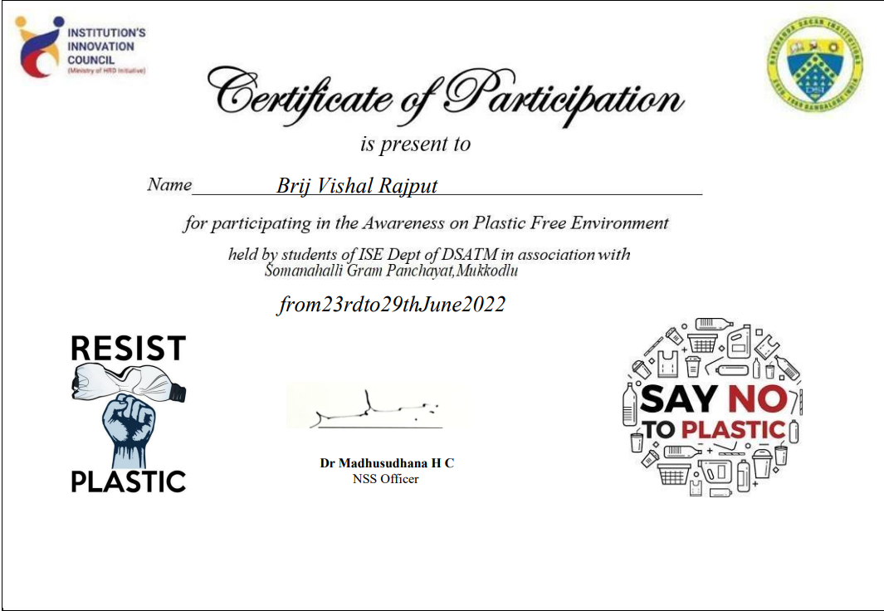

**Cyber safe girl**

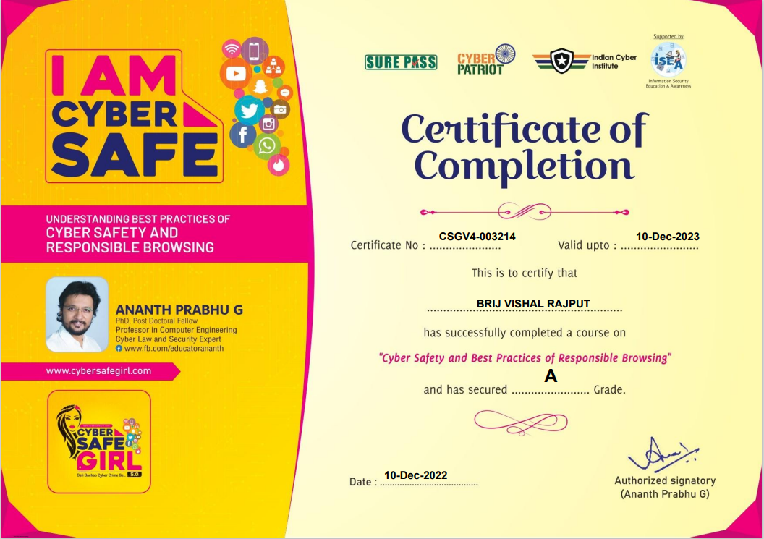

**Internship Program(Data Analytics)**

